# Math 76 Midterm 2

* Integration by Parts
  + ∫ udv = uv - ∫vdu
  + <https://www.integral-calculator.com>
  + Shell Method: 2 π ∫ x(f(x)-g(x))
  + Disc Method: π∫ (f(x)^2-g(x)^2)
* Integrating Products and Power rules
  + <https://www.integral-calculator.com>
* Integration by Trigonometric Substitution
  + Length: Sqrt(1+f’(x)^2)
  + <https://www.integral-calculator.com>
  + <https://www.symbolab.com/solver/trigonometric-substitution-integration-calculator/trigonometric%20substitution%20%5Cint%20dx>
* Partial Fractions
  + <https://www.symbolab.com/solver/partial-fractions-calculator>
* Table of integrals
  + <https://openstax.org/books/calculus-volume-2/pages/a-table-of-integrals>
* Midpoint and Trapezoid Approximations
  + Take the integral & Approximation and plug them in to get the Absolute/Relative Error.
    - <https://www.omnicalculator.com/statistics/relative-error>
    - 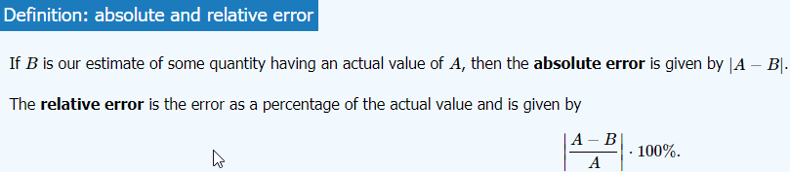
  + Midpoint: <https://www.emathhelp.net/calculators/calculus-2/midpoint-rule-calculator/>
  + 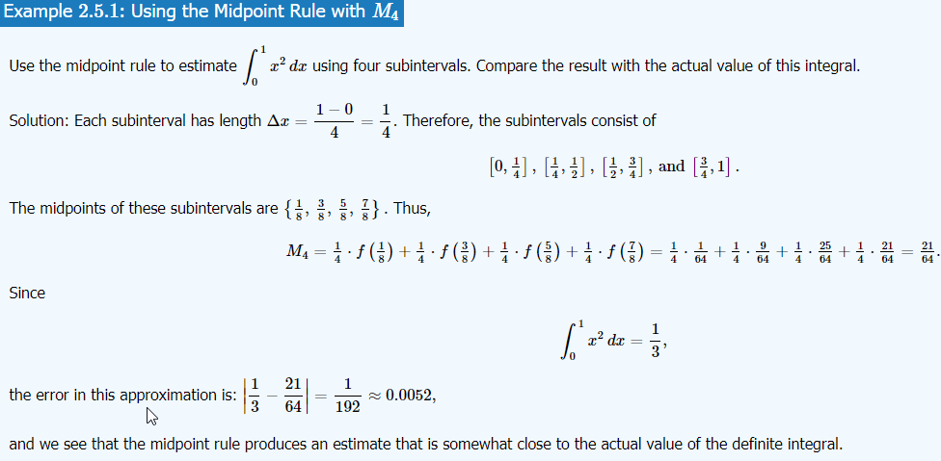
  + Trapezoid: <https://www.emathhelp.net/calculators/calculus-2/trapezoidal-rule-calculator/>
  + 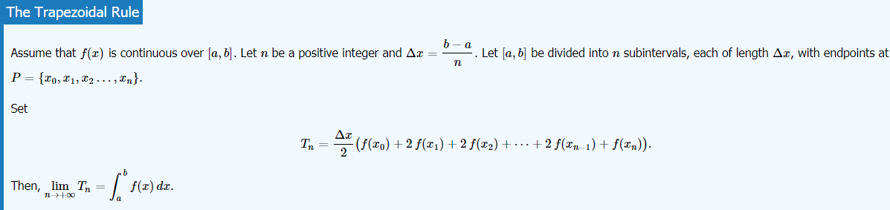
* Simpsons Rule
  + 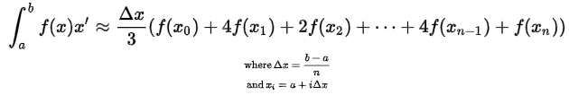
  + Take the integral & Approximation and plug them in to get the Absolute/Relative Error.
    - <https://www.omnicalculator.com/statistics/relative-error>
  + <https://www.emathhelp.net/calculators/calculus-2/simpsons-rule-calculator/>
  + 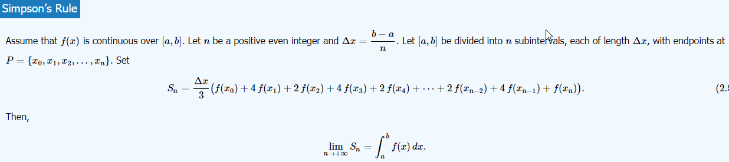
* Improper Integrals
  + <https://www.symbolab.com/solver/improper-integral-calculator>
  + <https://www.integral-calculator.com>